The website is vulnerable for the users as there are many defects and inconsistencies such as-

* Can be logged in without registration
* Can be logged in with invalid email address and data
* No authorization about the proper owner of the account
* Login with a wrong password
* Shortage of error messages and may not even detect errors sometimes
* Overall user interface should be improved like the size, navigation bar, and total representation is not fully user friendly.
* Functionality remains consistent across different browsers.

Account details, balance, and transaction history are displayed accurately but there is no way to check it as duplicate account can not be created despite of providing another email address-

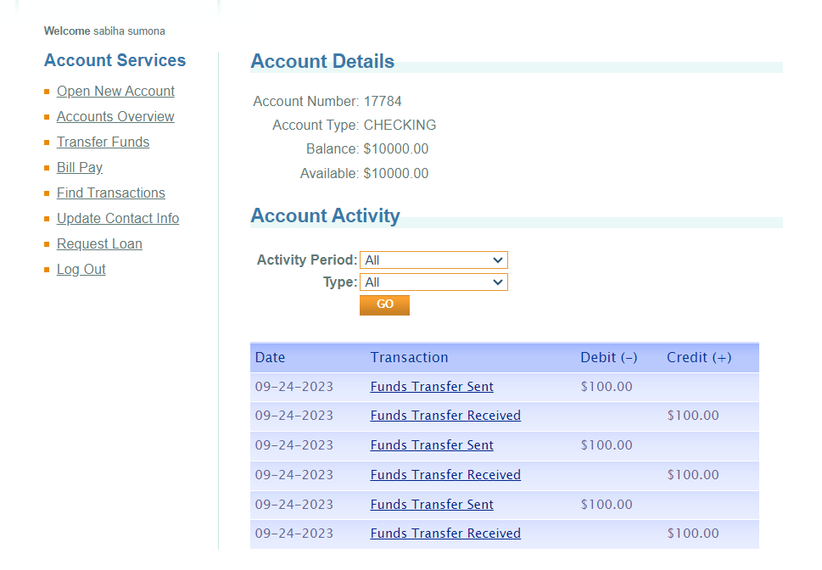

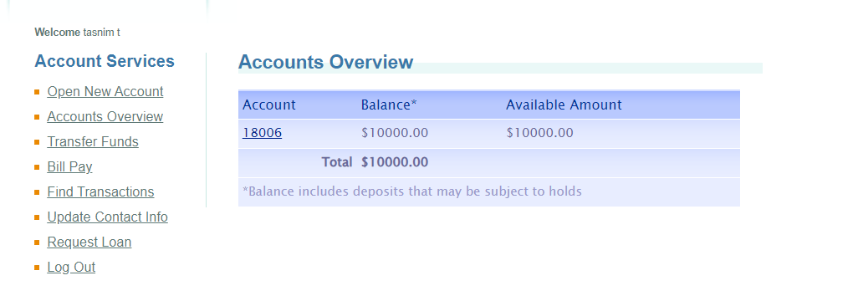

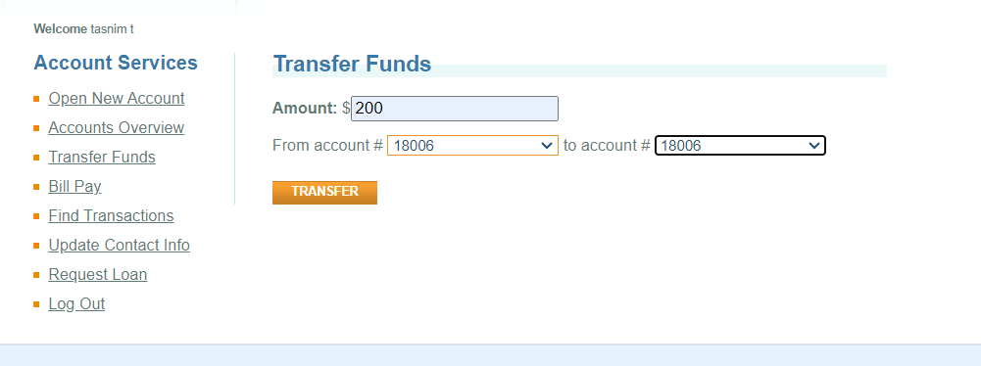

All the relevant screenshots of the mentioned errors have been attached below:

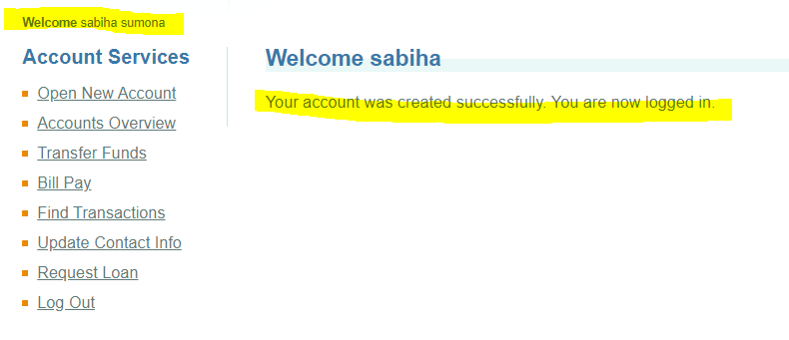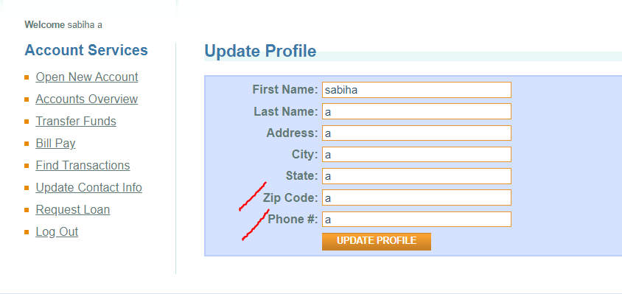

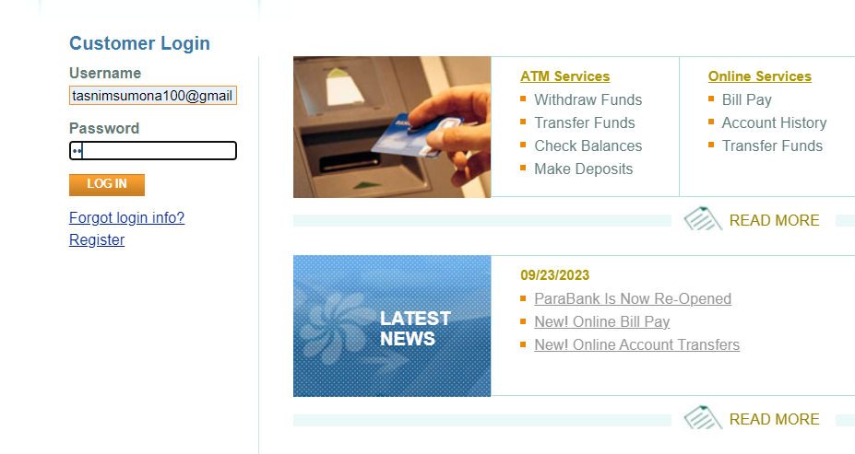

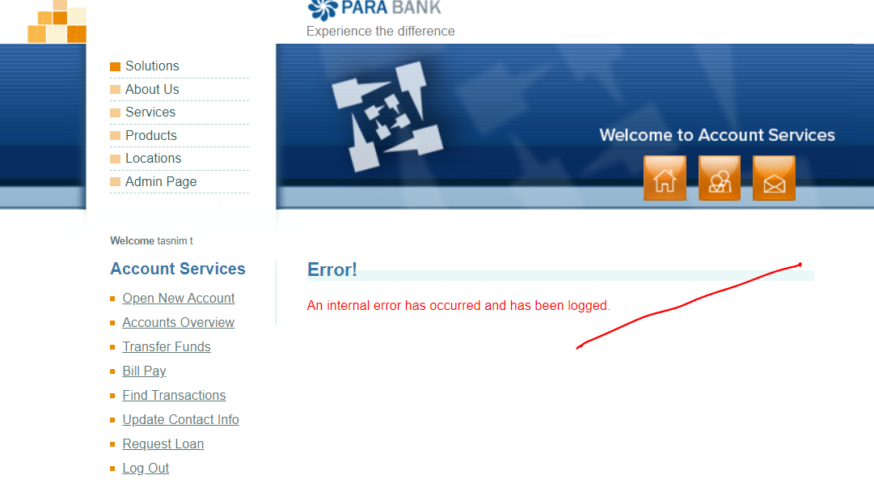

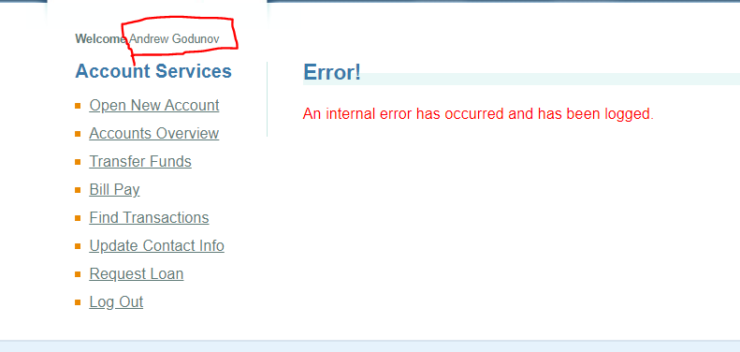

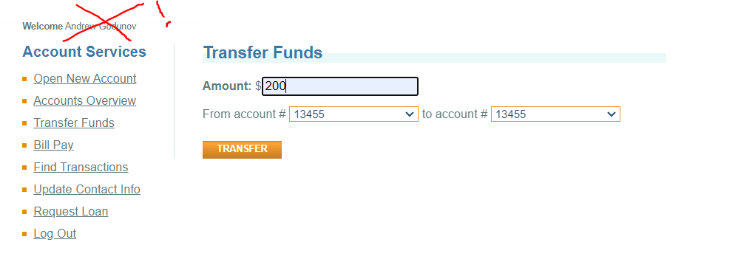

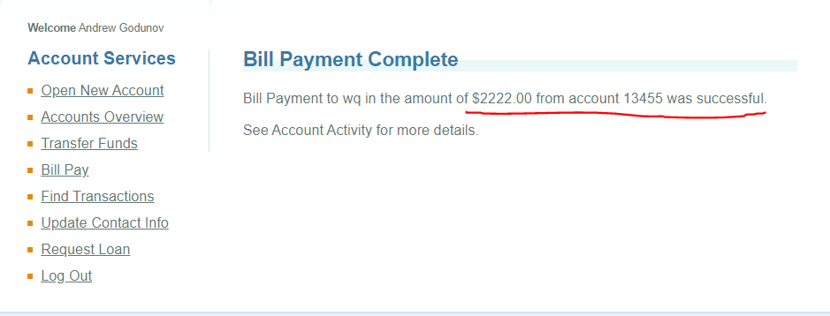

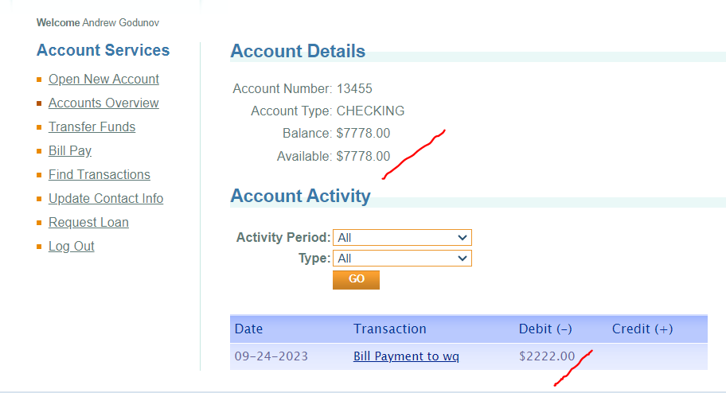

Success! Prev balance was 10,000

**Cross functionality test: (chrome and edge)**

Comment: functionality remains consistent across different browsers.

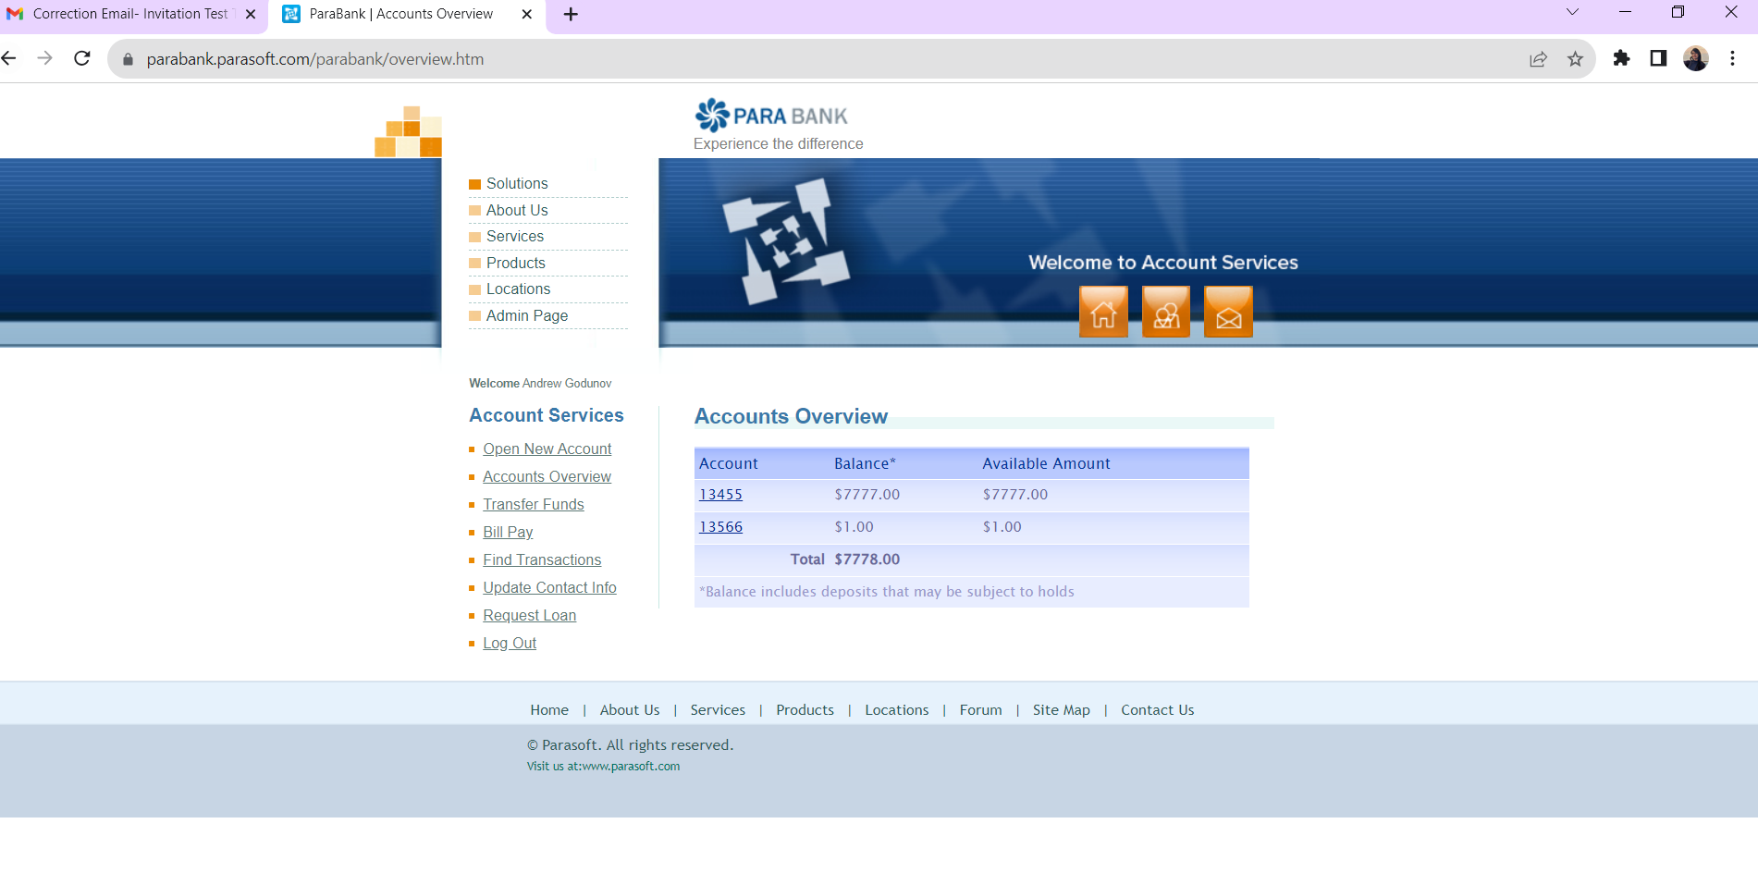

Chrome interface

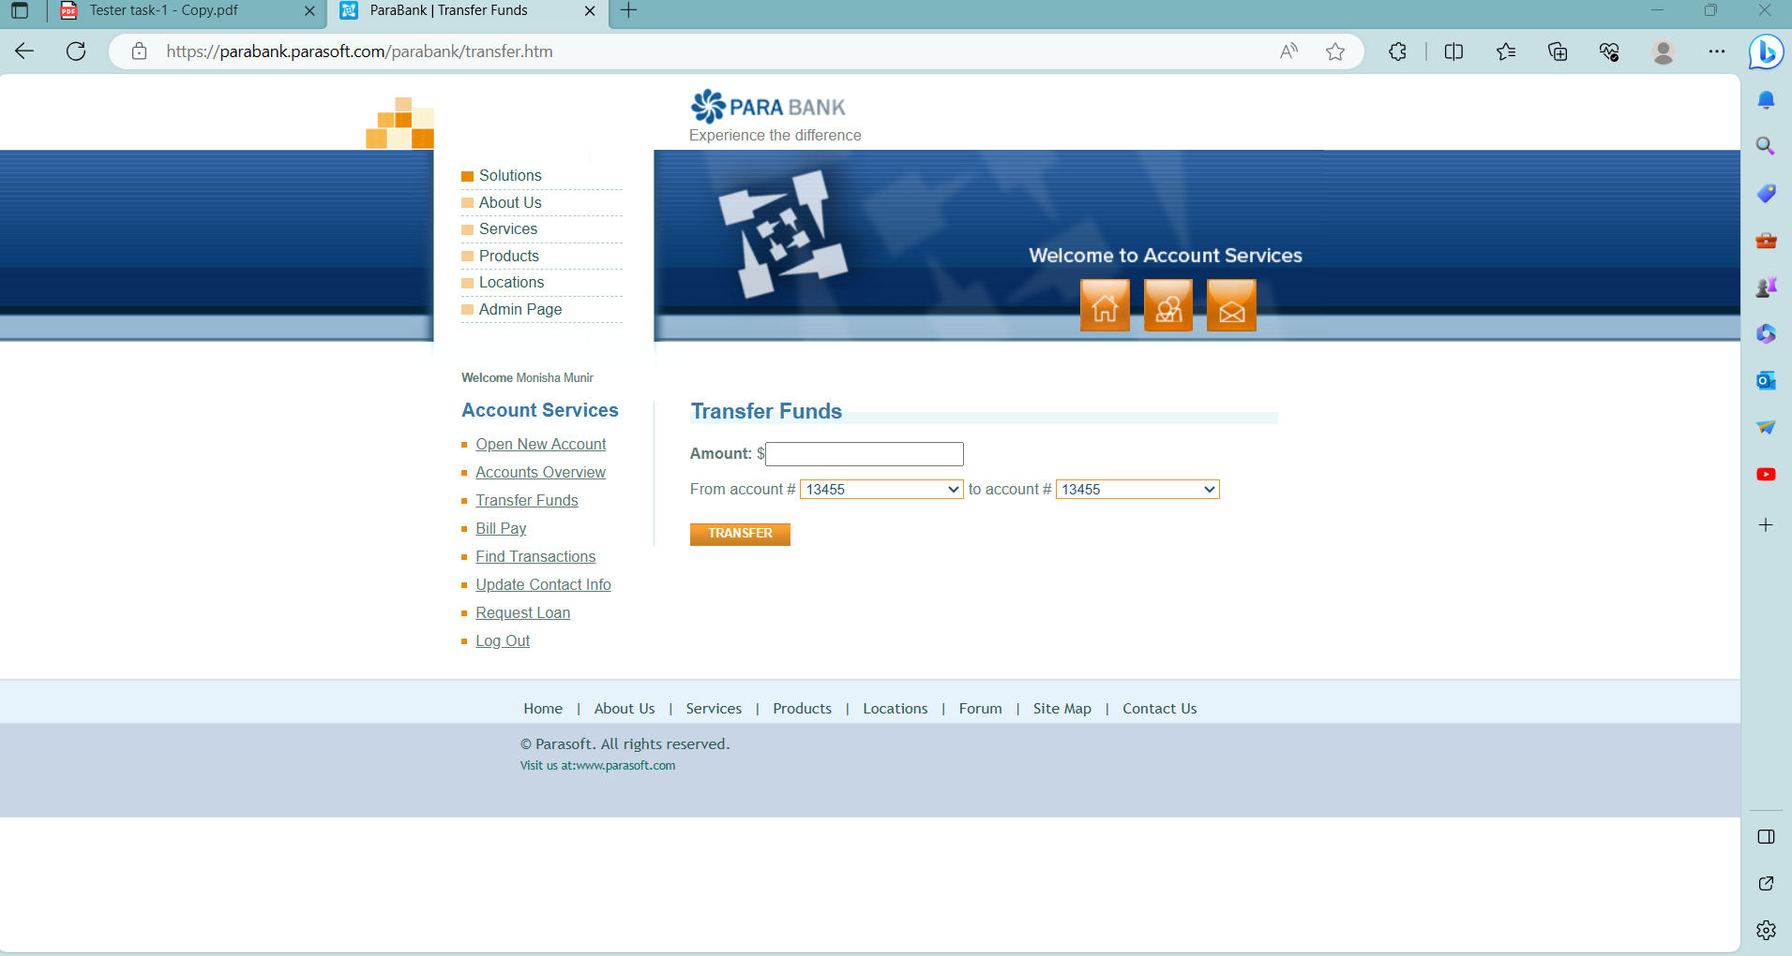

Edge interface